‘University Management System’
The ER Diagram represents the model of University Management System.The entity relationship
diagram of University Management System shows all the visual instrument of database table and
the relation between student,faculty,department ,course.Here are the requirements.
Requirements:
- The students are uniquely identified by their student ID.Furthermore they have a student name,CGPA and credit they completed.
- Each student is in a particular department.
- Each department is uniquely identified by their dept id.They also have their dept name too.
- Every exam conducted by department.
- Each exam have their course name,marks,student name and unique Reg No.
- Department offer courses.Each course have unique course ID.Furthermore they have course name and course credit also.
- Each student can select course by their personal choice.
- A department has many facilities.Each faculty works in particular department.
- Faculty are uniquely identified by their Faculty ID.They also have their faculty name,designation,hire date.
- Section assigned by each faculty.
- Each section are uniquely identified by section no.Furthermore they have section name too.
- Each section belongs to a particular course .
- The count of a total number of sections of a course must be kept.

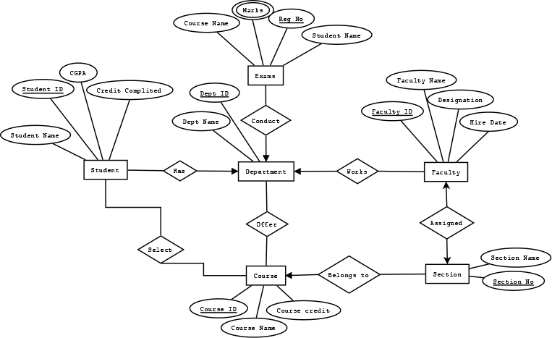
ER DIAGRAM

